Deep Learning GPU Workstations

24 Core AMD Ryzen Threadripper 4 GPU Workstation
This workstation is a fantastic all around deep learning workstation featuring an AMD Ryzen Threadripper 3960X 24 Core Processor. Acceleration is powered by up to 4X NVIDIA RTX 2080 Ti GPUs.
- Great for most deep learning researchers
- Budget friendly starting at $9,300

32 Core AMD Ryzen Threadripper 4 GPU Workstation
This workstation is another solid, all around deep learning workstation featuring an AMD Ryzen Threadripper 3970X 32 Core Processor. Acceleration is powered by up to 4X NVIDIA Quadro RTX 6000 GPUs.
- Great for developing any deep learning application
- Up to 96GB GPU memory
- Prices start at $19,599

Elite 64 Core AMD Ryzen Threadripper 4 GPU Workstation
Our most powerful AMD Ryzen Based Deep Learning Workstation goes beyond fantastic and is powered by a AMD Ryzen Threadripper 3990X 64 Core Processor. Acceleration is powered by up to 4X NVIDIA Quadro RTX 8000 GPUs.
- Train most deep neural networks including Transformers
- Up to 192GB GPU Memory!
- Prices start at $26,500
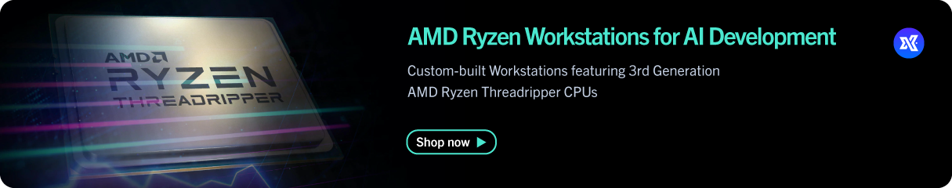
Contact: Felix Wong felix.wong@exxactcorp.com | (510) 266-7366 x207

