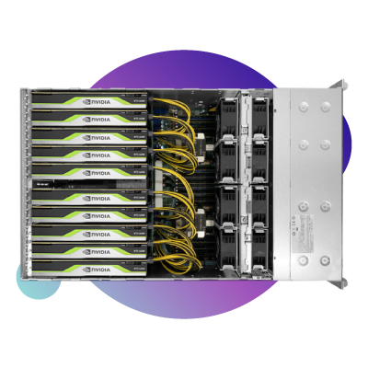
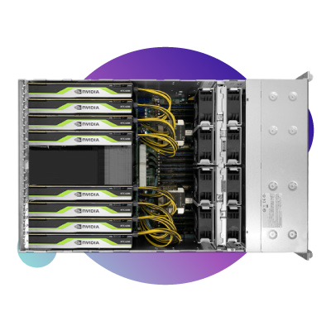
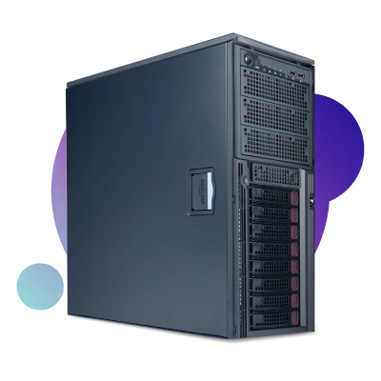
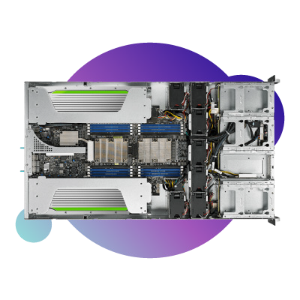
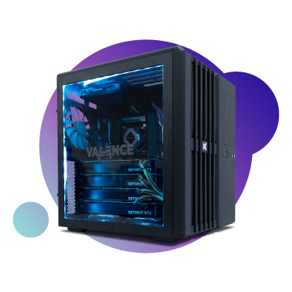
Deep Learning & AI Solutions
felix.wong@exxactcorp.com | (510) 226-7366 x207

 |  | Single Core-X i9 Quiet Workstation | Dual-Xeon SP Workstation w/ RPS | Dual-Xeon SP  Compact 2U GPU Server | Dual-Xeon SP 8x GPU 4U Powerhouse Server | Dual-Xeon SP 10x GPU 4U Powerhouse Server
 |  | VWS-1542881-DPW | TWS-773645-DPW | TS2-673917-DPN | TS4-672693-DPN | TS4-672702-DPN
 | Form Factor | Workstation | Workstation/ 4U Server | 2U Server | 4U Server | 4U Server
 | Max GPUs | 4x | 4x | 4x | Dual Root 8x | Single Root 10x
 | CPU | Intel Core X-Series | 2x Intel Xeon Scalable CPU | 2x Intel Xeon Scalable CPU | 2x Intel Xeon Scalable CPU | 2x Intel Xeon Scalable CPU
 | Memory | 8-Slots for up to 256GB DDR4 | 16-Slots for up to 4TB DDR4 | 16-Slots for up to 4TB | 24-Slots for up to 3TB DDR4 | 24-Slots for up to 3TB DDR4
 | Storage | 2x M.2 PCIe NVMe  4x 2.5" Internal  2x 2.5"/3.5" Internal 2x 5.25" External | 1x M.2 PCIe NVMe  8 Hot-Swap 3.5" Drive Bays | 1x M.2 PCIe NVMe  8 Hot-Swap 3.5" Drive Bays | 1x M.2 PCIe NVMe  24x 2.5" Hot-Swap Drive Bays | 1x M.2 PCIe NVMe  24x 2.5" Hot-Swap Drive Bays
 | Network | 2x 1GbE (RJ-45) Standard  2x 10GBase-T (RJ-45) Optional | 2x 10GBase-T (RJ-45) | 2x 10GBase-T (RJ-45) | 2x 10GBase-T (RJ-45) | 2x 10GBase-T (RJ-45)

Great for
Start ups Universities Research Labs Small Business
Small o ce with high CPU/memory demand
Universities Businesses
Businesses and universities with server racks in place
Multiple remote users
Businesses and universities with server racks in place
Multiple remote users
Large quantity GPU utilization
Businesses and universities with server racks in place
Multiple remote users
Large quantity GPU utilization

Starting at
$5,999
Starting at
$7,999
Starting at
$12,999
Starting at
$34,999
Starting at
$40,999
Revision: DL.8.20.1

CPU | 1x Intel i9-10900x 10-Core | CPU | 2x Intel Xeon Silver 10-Core | CPU | 2x Intel Xeon Silver 10-Core | CPU | 2x Intel Xeon Silver 10-Core | CPU | 1x Intel Xeon Silver 10-Core
 | 3.70 GHz |  | 2.40 GHz |  | 2.40 GHz |  | 2.40 GHz |  | 2.40 GHz
MEM | 64GB | MEM | 192GB | MEM | 192GB | MEM | 192GB | MEM | 192GB
OS | 2TB M.2 SSD w/CentOS 7 | OS | 2TB M.2 SSD w/CentOS 7 | OS | 2TB M.2 SSD w/CentOS 7 | OS | 2TB M.2 SSD w/CentOS 7 | OS | 2TB M.2 SSD w/CentOS 7
STG | Can be added | STG | 2TB HDD | STG | 2TB SSD | STG | 2TB SSD | STG | 2TB SSD
GPU | 2x NVIDIA 2080 Ti | GPU | 2x NVIDIA 2080 Ti | GPU | 2x Quadro RTX 6000 | GPU | 8x Quadro RTX 6000 | GPU | 10x Quadro RTX 6000

